CS4320 Semester Project

Project Description:

Semester Project working on Augur-View frontend and machine learning worker

Simon Schroeder (scsknb), Syed Tihaam Ahmad (tawm9), Noah Berry (nbbnt2), and [Sean Newell](mailto:spnm6b@umsystem.edu)(spnm6b)

Requirements:

* Create about page describing usage of Augur tools (see *About Page* requirement)
* Implement a count for Change Requests on table/card view (see *Change Request* requirement)
* Alter card view and dashboard layout (see *Card View,* *Dashboard View,* and *Repos Nav Button* requirement)
* Implement machine learning worker to create visualizations (see *Machine Learning Worker* requirement)
* Finish all requirements by monday after exam week (see *Semester Project* requirement)

| **Component** | **Priority** | **Requirement Name** | **Requirement Description** |
| --- | --- | --- | --- |
| Table View  Card View | Medium | Change Request Count | Implement a count of Change (Pull) requests on both the table and card view, similar to the current commit and issue counts. |
| About Page | Low | Information | Create a new page to display instructions and information about the CHAOSS project (including Augur). Should include where metrics are located, how they are measured, and how they are retrieved. |
| Machine Learning Worker | High | Machine learning visualizations | Utilize machine learning worker to establish new visualizations to add to dashboard view |
| Card View | Medium | Redesign Cards | Remake the card view. Delete impractical metrics. Possibly include a small visualization. |
| Dashboard View | Low | Tweak Dashboard | Slight redesign of dashboard view to allow for more visualizations (like the machine learning worker). Create dropdowns that encapsulate visualizations to utilize space better. |
| Semester Project | High | Date Requirement | Project must be finished by the Monday after finals. |
| Repos Nav Button | Low | Move Repos Button | Move view change to button on repos page as opposed to a dropdown on the navbar |

Use Case:

* Augur View Redesigned Frontend
* Description:
  + When the user accesses Augur, an about page describing the capabilities and tools should display. User then chooses which view to display data with various tools such as card view, table view, filtering, and even single repository dashboard statistics.
* Triggers:
  + User chooses a view for the stored repositories
* Actors:
  + Open source developers
  + Repository maintainers
  + System administrators
* Preconditions:
  + User successfully loaded website
  + User chooses data visualization
* Main Success Scenario:
  + User understands Augur’s capabilities through about page
  + All data is shown in a succinct manner
  + Filtering shows correct data
* Alternate Success Scenario:
  + User finds no repositories that fit filtering criteria (correctly)
* Failed End Condition:
  + Filtering doesn’t display correct results
  + Data organized confusingly
* Extensions:
  + Extended frontend redesign to change color scheme, ADA requirements, etc.
* Steps of Execution:
  + Create about page describing usage of Augur tools
  + Implement Change(Pull) Request count

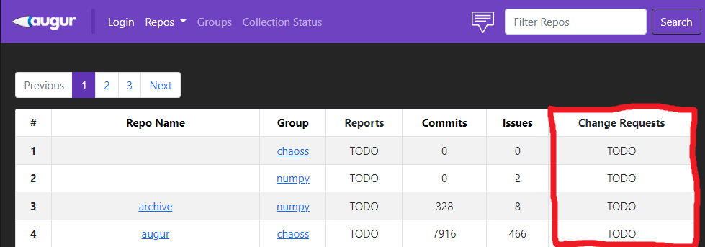

* + Alter card view and dashboard layout

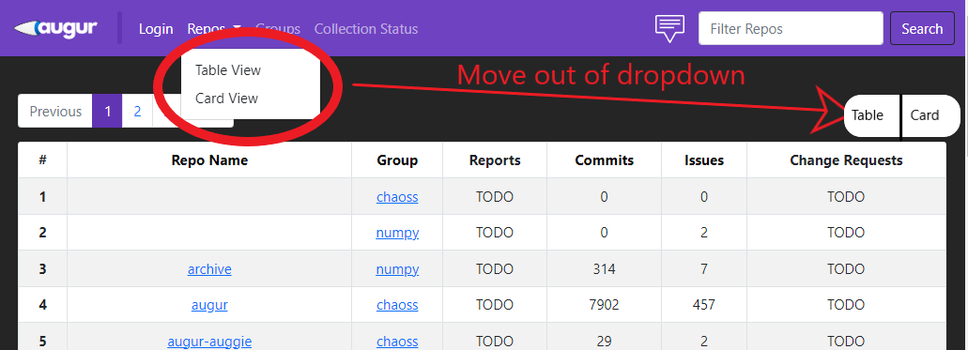

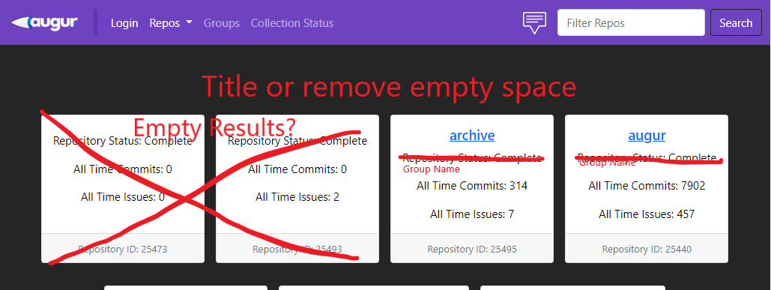

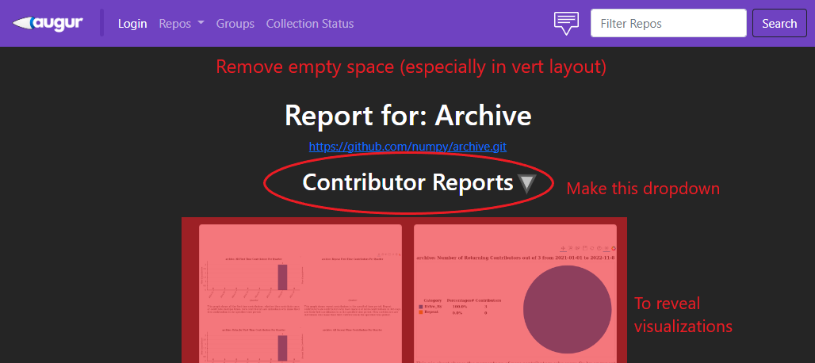

* + Implement machine learning worker to create visualizations
  + Finish all requirements by monday after MU exam week
* Use Case Diagram:

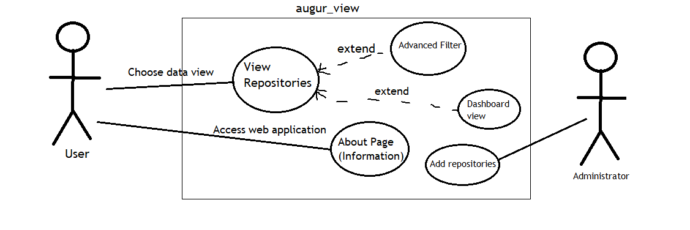

Link to Github Repository:

<https://github.com/Simon-SS/augur_view_group_12>

Group Development branch:

<https://github.com/Simon-SS/augur_view_group_12/tree/group12-dev>